**Student’s Project**

**MOROCCO**



**Taking Individual Actions for**

**Zero Hunger**

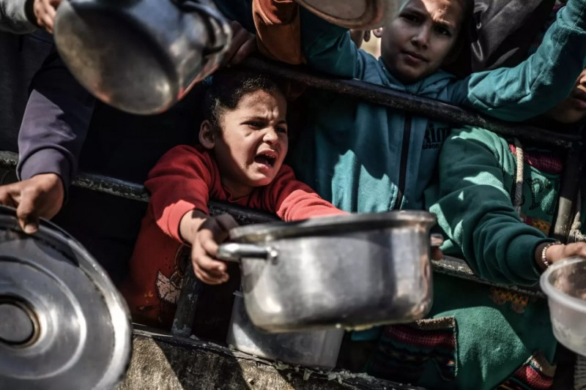

**The researcher : Walid Mzoughi**

Supervised by : Prof. Mohamed Fettah

School: Moulay Ismail High School

**Outline**

1. **Part One (Theory) ...........................................................**
2. **Introduction.**
3. An overview of zero hunger at the national and international level.
4. Impact of hunger on individuals and communities.
5. **Challenges in achieving zero hunger.**
6. Climate change and its effects on food production.
7. Spread of food insecurity and malnutrition.
8. Reproduction of poverty and lack of resources.
9. **Strategies to combat hunger.**
10. Promoting sustainable agriculture.
11. Reducing food waste.
12. Engaging local farmers and communities in sustainable development goals.
13. **A case study.**
14. Identifying a poor family facing hunger in Meknes.
15. Understanding its needs and struggle.
16. Highlighting successful interventions in similar contexts.
17. **Part Two (Practice) ....................................................**

* **Organizing a school campaign to raise awareness about zero hunger.**
* **Creating posters and presentations on hunger issues.**
* **Sharing the story of the targeted family to inspire empathy.**

**Abstract**

**Hunger is a global crisis that affects millions of individuals and communities in the last few years. The United Nations’ Sustainable Development Goal 2 (Zero Hunger) aims to eradicate hunger and ensure access to nutrition for all. In Morocco, hunger continues to affect vulnerable families especially in rural areas.**

**As a matter of fact, several challenges impede the realization of Zero Hunger. For example, climate change significantly disrupts food production and leads to unpredictable weather patterns, reduced crop yields, and soil degradation. These environmental changes exacerbate food insecurity and malnutrition, particularly in regions already struggling with poverty. Indeed, addressing these interconnected challenges requires a comprehensive approach that tackles both the symptoms and causes of hunger.**

**In addition, the research sheds the light on certain strategies that contribute to long-term food security and resilience against future crises. For instance, promoting sustainable agriculture is a key strategy to combat hunger. Also reducing food waste and developing sustainable farming practices enhance food security for vulnerable families. Additionally, engaging local farmers and communities in sustainable development initiatives fosters solidarity and cooperation between people.**

**This research also introduces a poor family in Meknes which provides a vivid example of the daily struggles faced by this family against hunger. The family’s lack of resources highlights the challenges of accessing adequate food, education, and healthcare. By examining similar contexts, this research identifies successful interventions such as targeted food assistance programs, education initiatives, and capacity-building efforts for local people. These interventions demonstrate how community-based approaches can break the cycle of hunger and poverty as well as improving the quality of life in general.**

**Ultimately, eradicating hunger requires coordinated efforts at the local, national, and international levels. Policymakers must prioritize investments in sustainable agriculture and infrastructure, while communities must engage in initiatives that promote food security and resilience. International cooperation is also crucial for ensuring the sharing of resources, knowledge, and technologies to address global hunger.**

"The endurance of a society depends on justice and the provision of basic needs for its people."

Ibn Khaldun